Distance Learning Plan

Grade 8 Science
Week 9

Introduction

Welcome to another week of distance learning!

Week 9: Unit 6 - Waves and Their Applications
During Week 9, you will explore the topic of modeling waves through various mediums. You will:
- Reflect on the phenomena of how we can see the light of the sun’s explosions but not hear them
- Explore speed of sound to infer how it is impacted by the medium*
- Read the STEMscopedia and create a haiku around your learning
- Construct a claim-evidence-reasoning response to why we cannot hear the sun
*Access to a computer is required. Activities are organized and labeled by day.

Accessing the STEMscopedia
The STEMscopedia is the primary text within STEMscopes, your science curriculum resource. You have likely been reading excerpts from it all year. You can access the STEMscopedia on STEMscopes via Clever. Sections relevant to this week are also posted online at http://bit.ly/DCPSscienceathome.

Using STEMscopes via Clever
By default, the STEMscopedia is turned on for all units. Your teacher does not need to assign it to you. You can access STEMscopes online through Clever.
- Go tohttps://clever.com/in/dcpsk12
- As your username, use your DCPS student ID number.
- As your password, use your date of birth (mmddyy).
- Find the “STEMscopes” icon to get started.
- Select “Learning Resources” at the top of the page.
- Search for the name of the topic you are reviewing (e.g., Modeling Waves).

Optional Extended Learning Opportunities (Science)
You can also explore a list of science learning activities that you can complete at home. These Science Extensions can be found at http://bit.ly/DCPSscienceathome in the Grade 8 folder.

Week 9: Day 1 – Engage: Investigative Phenomena

How can we see explosions on the Sun but cannot hear the Sun?
Directions: Observe the picture of the sun below. What are your wonderings? Generate questions and possible answers to the above phenomenon in the “Before Instruction” column of the table. As you move through the scope, you will learn info needed to describe the events happening in Investigative Phenomena. Each time you learn something new, jot down how the info relates to the phenomenon.
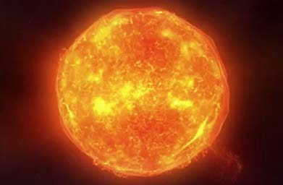
Student Wondering of Phenomena:

Before Instruction | During Instruction  (Refine your thoughts as you learn more throughout the scope. | After Instruction

Describe how the sound of the person shouting will move through the water:
Describe how the sound of the person shouting will move on the surface of the Moon (which has very little atmosphere).
Science Distance Learning Plan

Week 9: Day 1 – Engage: Activating Prior Knowledge

Modeling Waves through Various Mediums
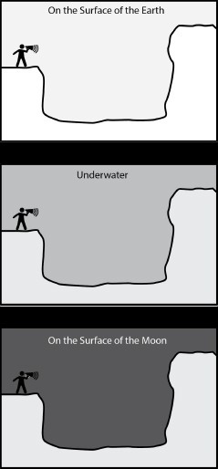
In each of the situations modeled below, a person standing on a cliff is shouting across a canyon. Describe how the sound might behave in each situation. Are there situations when no echo will be produced?
Describe how the sound of the person shouting will move through the air on the surface of the Earth:

Science Distance Learning Plan

Week 9: Day 2 – Explore: Tuva Speed of Sound
To access Tuva, please click on or copy and paste this link: https://bit.ly/TuvaSound

Sound is a type of energy that can move from place to place. Sound energy cannot travel through a vacuum, but it can move through various mediums—solids, liquids, and gases. The velocity of sound is dependent on the properties of the medium through which it travels, such as its density.

Procedure:
This dataset contains information about the speed of sound through various materials.
- Think about these questions:
  - Through what mediums do sound waves travel?
  - How does the medium through which it travels affect the velocity of sound?
- Make sure you have accessed the Tuva Data Set Speed of Sound.

- Click on the little pencil next to the “Material” label. How many different materials are included in this data?

- Click on the “Graphs” menu, and select the best visual tool to illustrate the percentages of liquids, gases, and solids found in this data set. Which is the best tool for this displaying this data? Explain your answer.

- Drag the “State of Matter” label to the area that is to the right of the graph, and select “Percent by Pie Section,” from the “Stats” menu. For which medium was the most data collected? What percentage was it?

  - Click Reset. Select the appropriate visual tools to carry out the rest of this investigation.
  - Provide data evidence wherever possible when answering the questions.

- Through which material is the velocity of sound the greatest?

  - Click Reset. Compare the velocity of sound as it travels through the various mediums (solids, liquids, and gases).

- Select “Median” from the “Stats” menu. What is the median velocity of sound through gases? Liquids? Solids?

- What can you infer from this data? (HINT: Think in terms of density of the matter.)

*Refer to the Investigative Phenomena question, anchor your learning, and revise your thinking.

Science Distance Learning Plan

Week 9: Day 3 – Explain: Linking Literacy & STEMscopedia

Leading Ideas for Wave Travel
Directions: Use this sheet to organize leading ideas and the details of those ideas from the passage while reading STEMscopedia Waves through Various Mediums. (Looking at the title of the passage, focus on the different mediums through which waves can travel.)
Details:
Details:
Details:

Leading Idea
Leading Idea
Leading Idea

Overall Idea:

*Refer to the Investigative Phenomena question, anchor your learning, and revise your thinking.

Modeling Waves through Various Mediums

Some waves need a medium to travel. What do the images of the circular waves in a pond and sunlight streaming down have in common? Both the water ripples and rays of sunlight are examples of waves that transfer energy, but how they do that is very different. Some waves need a medium to travel, while others do not. Waves such as water must transfer energy through a medium; they are called mechanical waves. Waves such as sunlight can transfer energy through empty space and do not need a medium; they are called electromagnetic waves.

Ripples are mechanical waves, while rays of sunlight are electromagnetic waves.

Sound waves, like other mechanical waves, transfer energy through a substance called a medium. The medium does not make the wave. The particles in a medium become disturbed and pass on this disturbance to the next one, and so on. So, the disturbance caused by the particles can travel through a medium such as air, ocean water, land, violin strings, Slinky coils, etc. Sound waves can travel through solids, liquids, or gases.

A source creates a wave, not a medium. Waves are created when a source (force) generates a vibration. Vibrations in materials set up wavelike disturbances that spread away from the source of the disturbance. This means that every wave starts somewhere. For example, in the picture above, the speaker generates the sound waves, not the air in which they travel. Waves are moving energy.

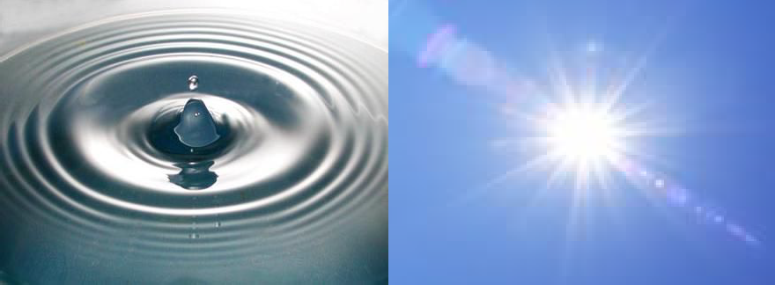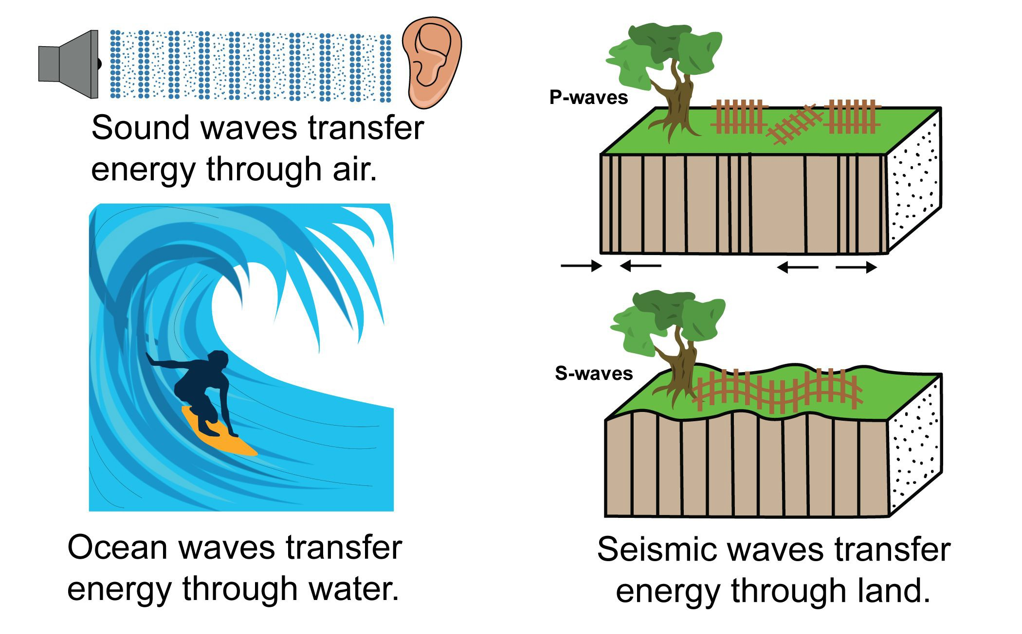
The speed of sound depends on the medium. The type of matter that a wave travels through determines the speed of the wave. You can shout as loud as you want, but your sound will only travel through air at 343 meters per second. As a source of energy begins the vibration of the wave, the matter around it is disturbed. Each disturbance is passed to the matter next to it, so that energy flows away from the source in a wave. Remember: waves transfer energy, not matter. Referring to the chart on the right, which state of matter transfers sound the quickest: solid, liquid, or gas?

The Speed of Sound in Various Mediums

Medium | Temperature (°C) | Speed (m/s)
Air | 0 | 331
Air | 20 | 343
Water | 25 | 1493
Salt Water | 25 | 1533
Rubber | 25 | 1550
Iron | 25 | 5130

1

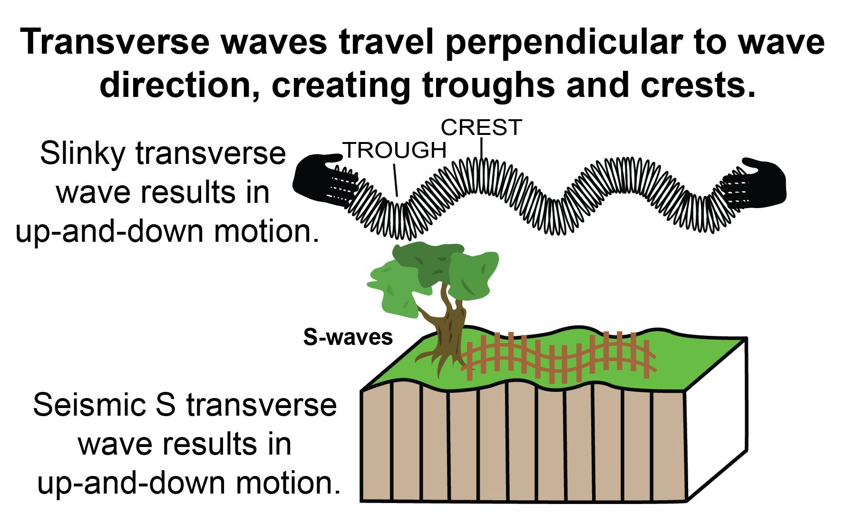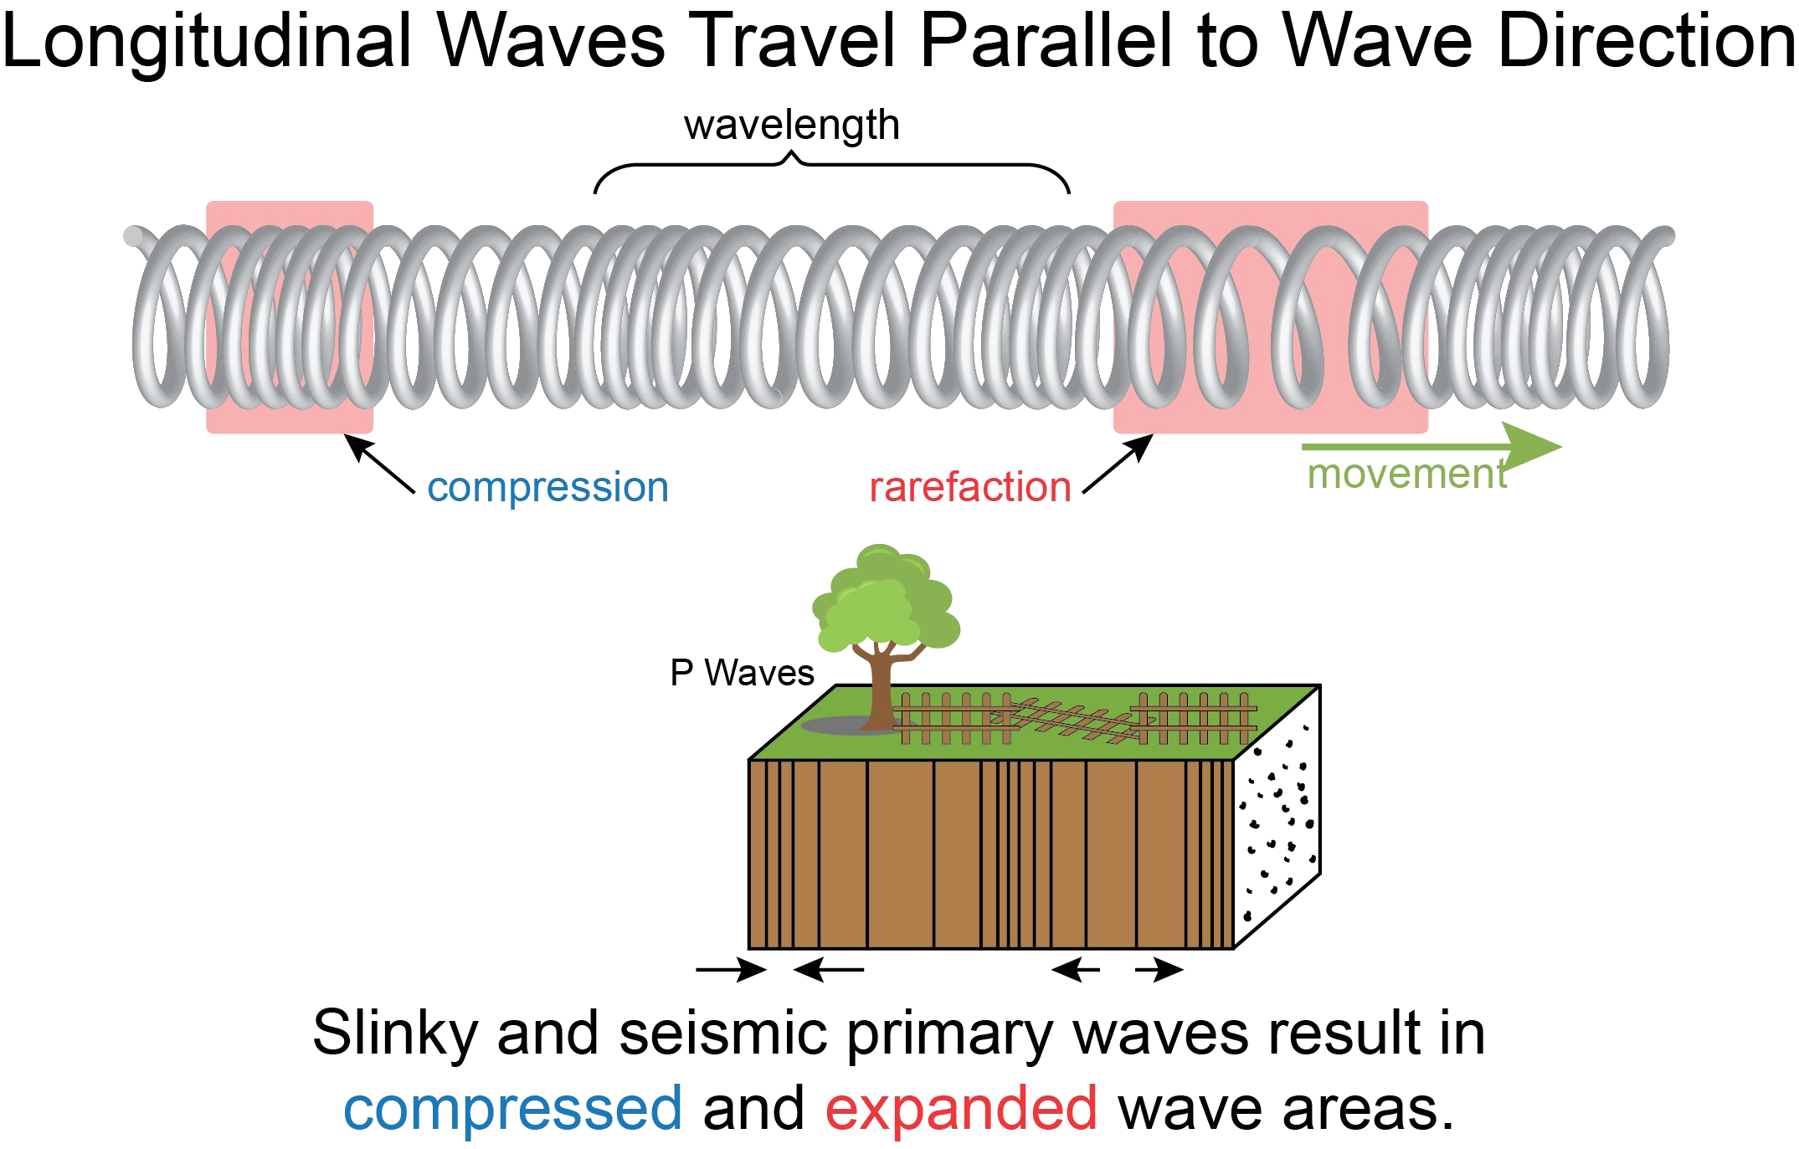Modeling Waves through Various Mediums

Different types of waves can be compared by the way they behave. Waves have a repeating pattern that gives them a shape and length. These characteristics allow us to describe wave behavior and categorize mechanical waves as transverse (such as the vertical, up-and-down movement of a spring toy) or longitudinal (such as the horizontal compression and expansion of a spring toy).

Transverse Waves
Transverse waves travel in a direction perpendicular (up and down) to the wave direction. Mechanical transverse waves cannot propagate in a fluid (a gas or liquid), because there is no mechanism for driving motion perpendicular to the propagation of the wave (sideways, or left to right). Consequently, mechanical transverse waves are transmitted only through solids. Characteristics of transverse waves include the following.
Crest: The highest point of the transverse wave
Trough: The lowest part of a transverse wave
Amplitude: The maximum distance that the particles of a wave’s medium vibrate from their rest position, which is called the equilibrium; half the vertical distance between the crest and the trough; larger waves have more amplitude and carry more energy
Wavelength: The distance from any point on a wave to an identical point on the next wave Frequency: Equals the number of waves that pass a given point per second (measured in hertz) Transmission: Only through solids

Longitudinal Waves
Longitudinal waves travel in the same direction as
the wave energy compresses and expands particles. Characteristics of longitudinal waves include the following.
.
Condensations (compressions): Regions of high density
Rarefactions: Regions of low density
Transmission: Through solids, liquids, or gases
Condensations and rarefactions oscillate around local positions of equilibrium parallel to the path of energy transfer. Because the waves compress fluids, another term for a longitudinal wave is a compression wave. Fluids (air and liquids) transmit only longitudinal waves, such as sound.
Examples of longitudinal waves are a Slinky, ocean waves, primary (P) seismic earthquake waves, and sound waves in the air.
2

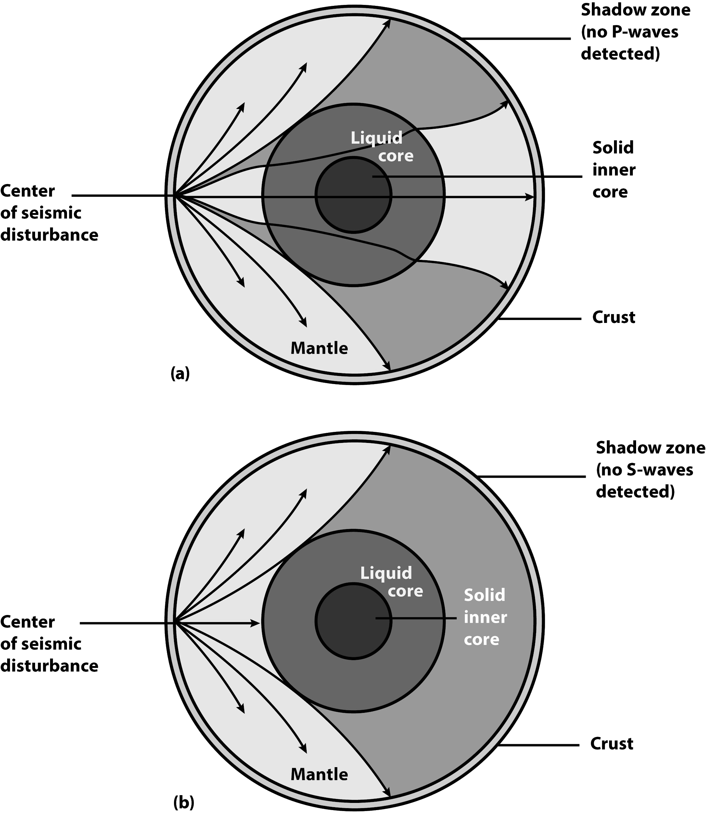Modeling Waves through Various Mediums

When a wave is created in a solid, such as in Earth’s crust, matter is already tightly packed, which allows waves of energy that cause particle disturbances to move more quickly through solid materials.

The picture of Earth below shows an earthquake and the path that the seismic waves take as they travel away from the epicenter. Since the waves are traveling through a solid, they move quickly. Each of these waves changes its speed according to the changes in the rock that it travels through. Do you think the waves that travel nearest to the core travel faster or slower than the waves that are nearer to the crust? The shadow zone results in P-waves (longitudinal waves) being bent (refracted) by the liquid core shown in (a) and S-waves (transverse waves) being stopped entirely shown in (b).

Why do you think geologists were able to use these P and S seismic waves to confirm that the outer core is liquid? Write your answer below.

3

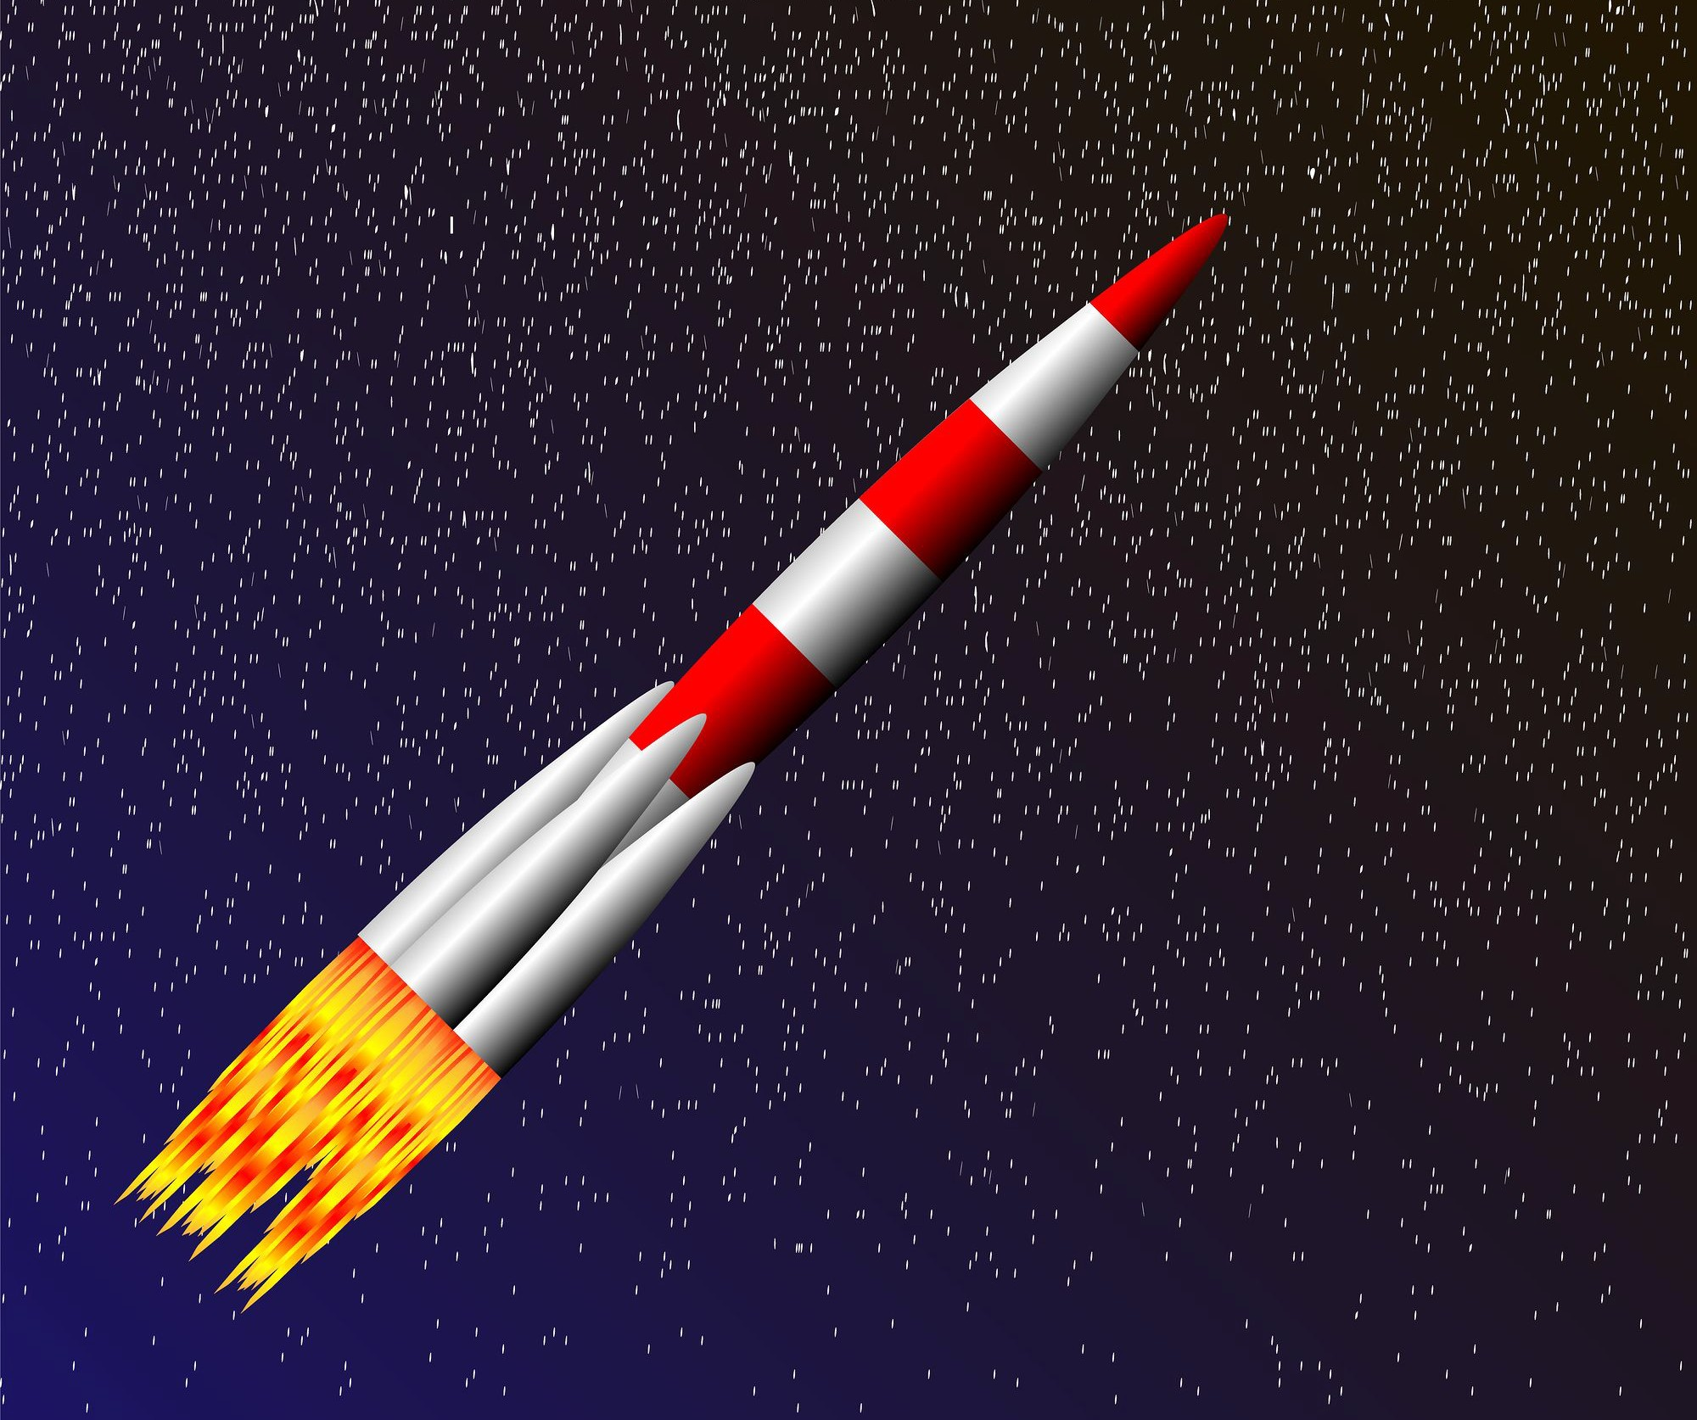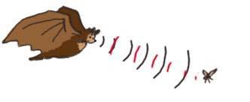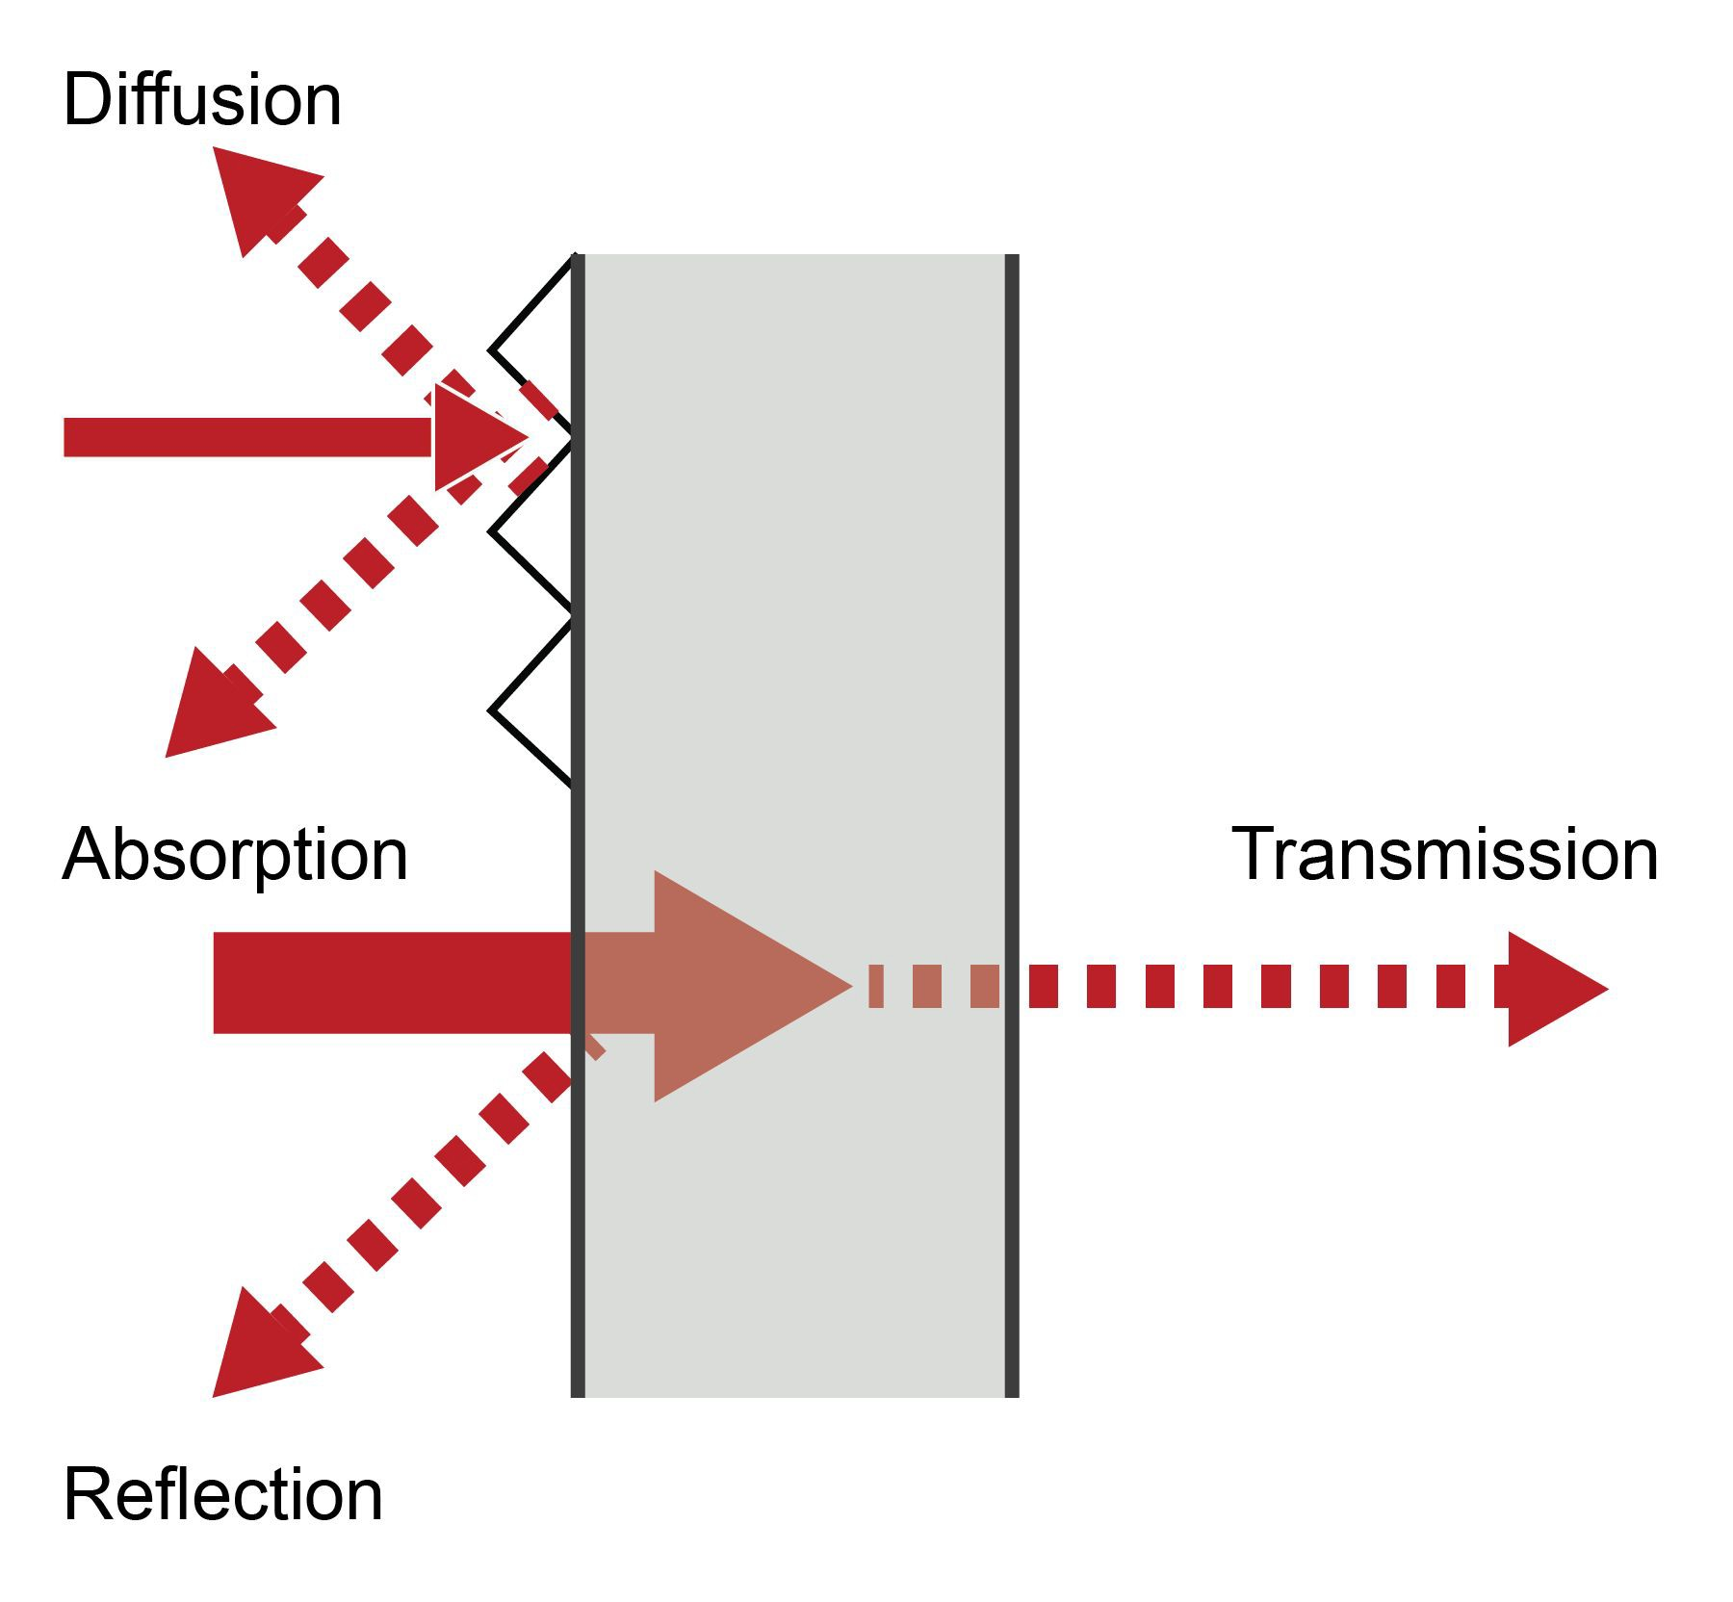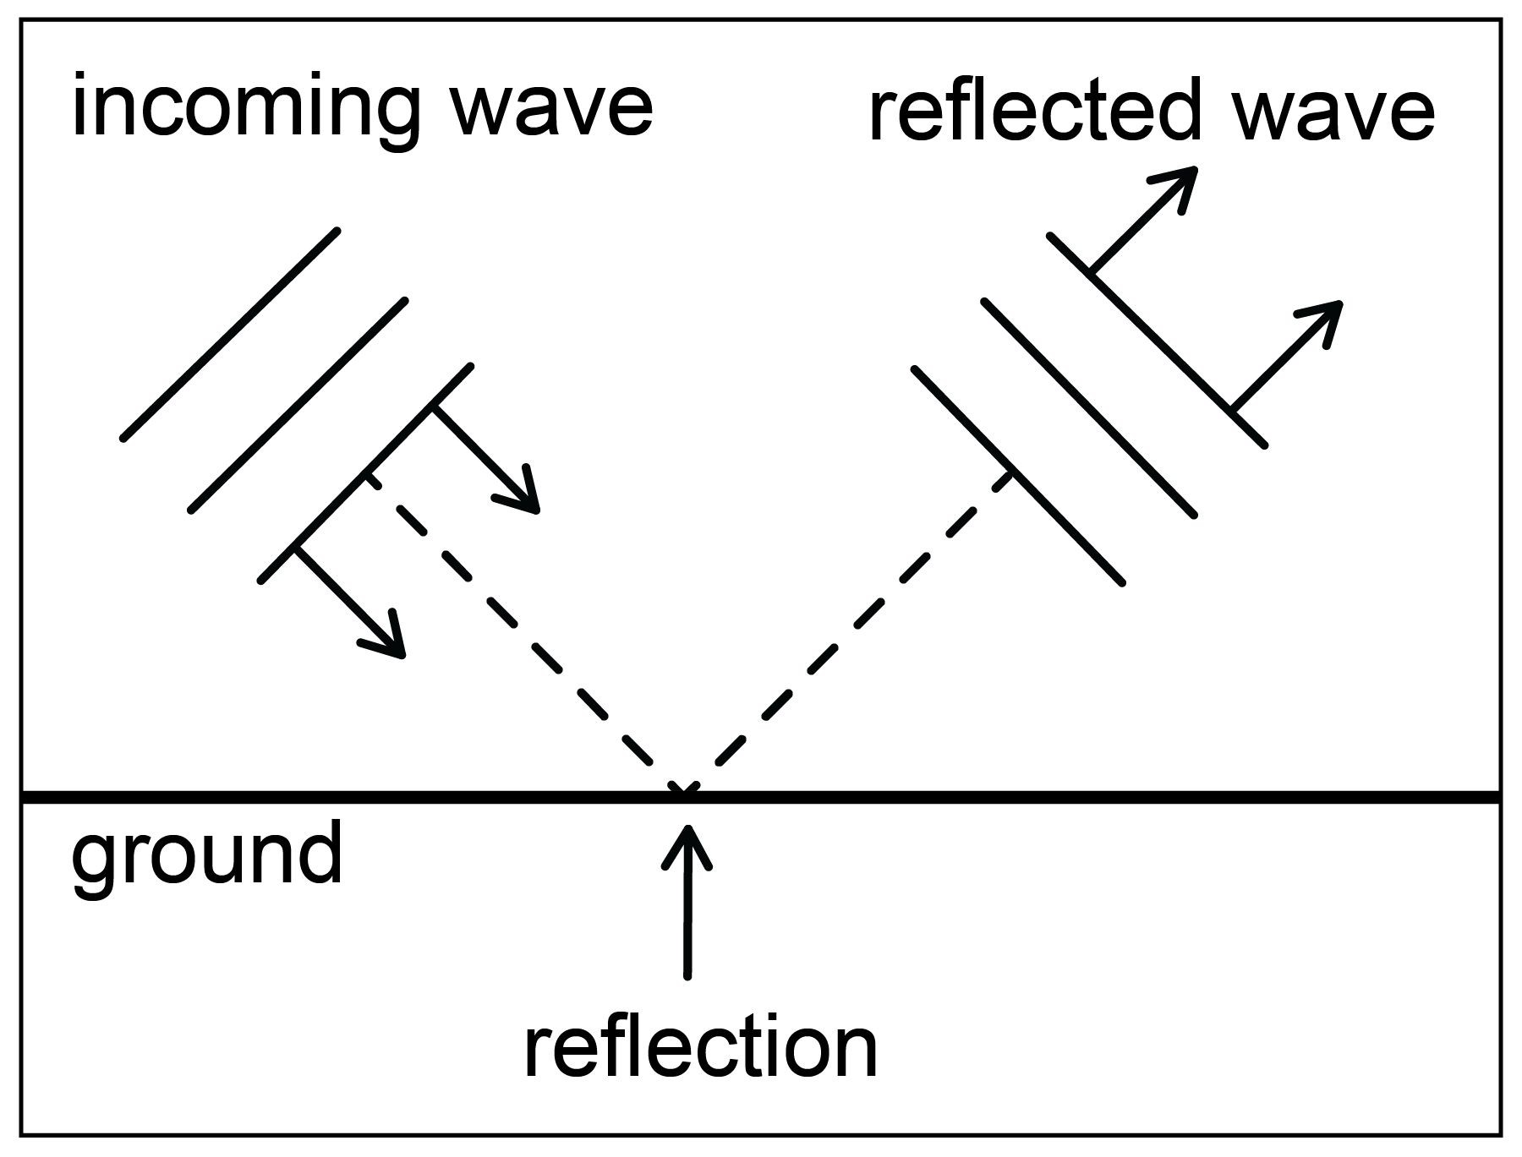Modeling Waves through Various Mediums

It’s all in the medium. How sound waves are reflected (bounce back), are absorbed (stop within the medium), or are transmitted (pass through) depends on the mediums they encounter. Smooth surfaces reflect sound more clearly, while rough surfaces can diffuse sound (reflect in many directions). Porous or soft materials absorb more sound than smooth surfaces. Thin materials or metal materials allow more transmission than thick or nonmetal mediums. Denser materials transmit sound better than less dense materials. Therefore, solids transmit sound better than liquids, and liquids transmit sound better than gases.
Can you hear it? In the cartoon space rocket on the left, why do you think you would not be able to hear the whoosh of the rocket engine in space?

In old western movies, you sometimes see one of the cowboys putting his ear down to the ground to listen for approaching horses. Why would the ground be a better transmitter than the air for the approaching sound?

Imagine sound waves coming from a stereo speaker. The sound reaches a large, mirrored wall. What do you think will happen to the sound? The music sound waves reflect off the smooth surface at the same angle at which they hit the surface. This follows the law of reflection, which states that the angle of the incoming wave equals the angle of reflection. In a smaller room, such as a bathroom, the reflected sound can reverberate (echo in many directions) off the smooth tile. Why do you think people enjoy singing in the shower?

Reflection from a Distance
When sound reflects off distant canyon walls, sometimes you can hear an echo. Sound travels very fast, but to create an echo, the distance must be at least 75 meters. Animals such as bats and dolphins use their sensitive hearing to detect and locate echoes from objects by emitting usually high-pitched sounds that bounce back to their ears. This animal sonar is called echolocation.
4

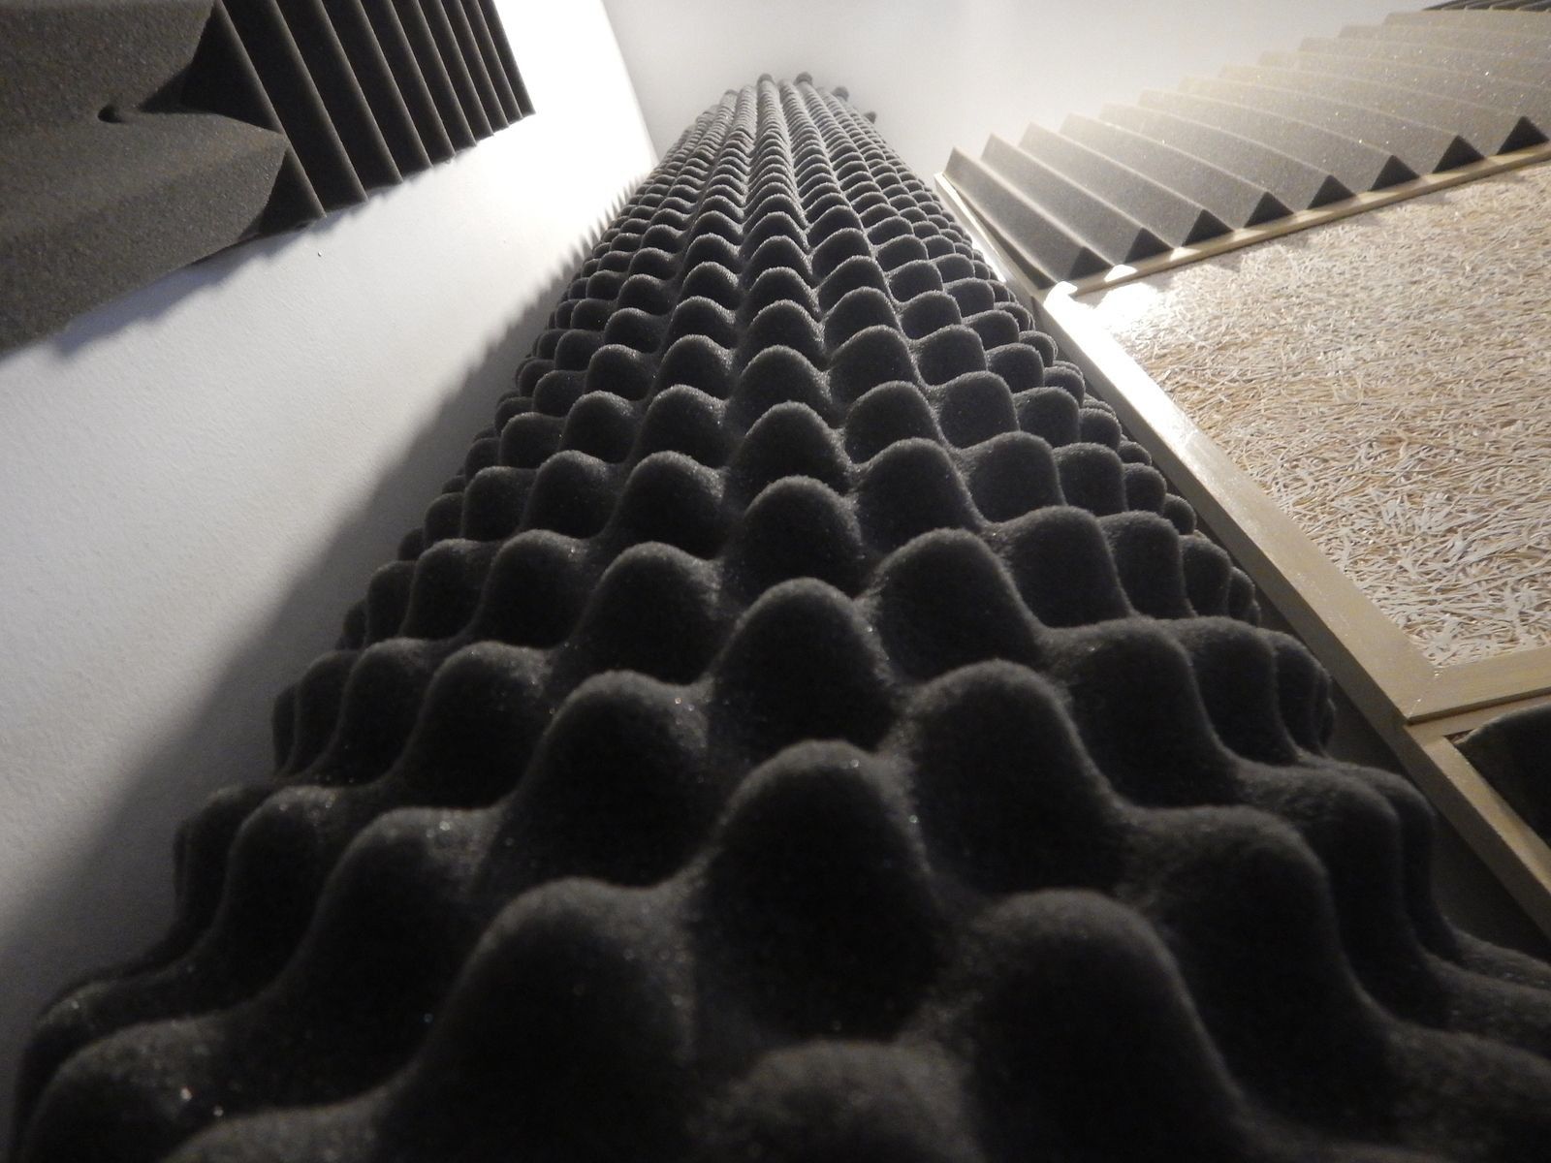Modeling Waves through Various Mediums
Absorbing Sound
Too much reflected sound can be a nuisance in some places. Acoustical engineers who specialize in sound control will often use porous ceiling tiles, eggcrate foam tiles, or pleated drapes to absorb sound in movie theaters, concert halls, and office areas.

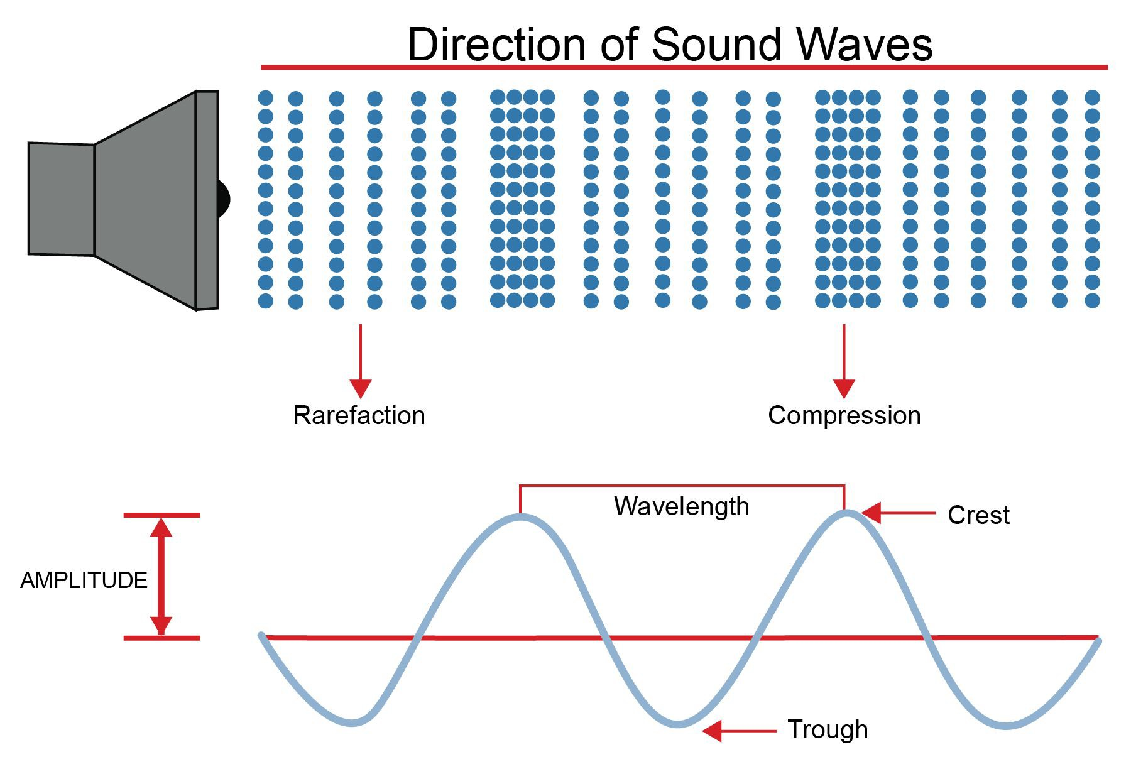
Even though sound waves travel as longitudinal waves, you may sometimes see them drawn as transverse waves, with the areas of compression represented by crests and the areas of rarefaction shown by troughs. With that type of graphic, the amplitude (loudness) and wavelength (pitch) of the sound are easier to understand.

5

Science Distance Learning Plan

Week 9: Day 4 – Explain: Post-Reading Haiku
Directions: A haiku is a three-line poem in which the first and third lines have five syllables and the second has seven syllables. Summarizing what you learned from the reading, write a haiku. Here is an example:
Title: Waves
What ways can waves move? Longitudinal compress Transverse up and down

Title:

(5 syllables)

(7 syllables)

(5 syllables)

Week 9: Day 4 – Evaluate: Claim-Evidence-Reasoning
Scenario
The Sun constantly undergoes explosions called solar eruptions. When a solar eruption happens, satellites capture images of bright flashes of light called solar flares. Solar eruptions emit more energy than millions of megaton hydrogen bombs. Space is a vacuum and void of any matter.

External Data
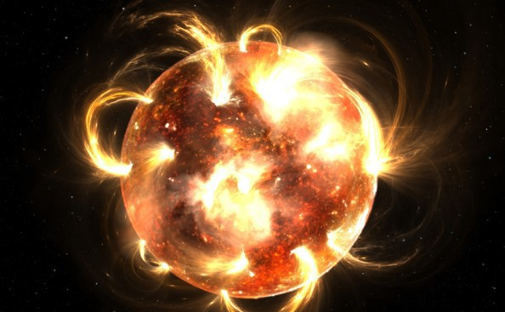

Prompt
Write a scientific explanation on why we don’t hear solar eruptions on Earth.

Claim:

Science Distance Learning Plan
Evidence:

Reasoning:

