Subject: | Health Education
Title: | Emergency Preparedness
Grade: | K-2

Standards
1, 3 | Students will comprehend concepts related to health promotion and disease prevention to enhance health  Students will demonstrate the ability to access valid information and products and services to enhance health

Essential Question
What can you do to keep yourself safe from germs?

Rationale
Germs are tiny living organisms that can make us sick if we don’t know how to protect ourselves from the harmful ones. It is important that students learn about germs and how to avoid them.

Tasks
- Illustrate and describe how skin protects the body from germs.
- Demonstrate proper hand-washing techniques and explain the importance of washing hands.

What could happen to us if we didn’t have our wonderful skin? Let’s find out by watching these two apples. The first one has a shiny skin protecting the soft inside part of the apple. But let’s peel the skin off of this other apple and see what happens to it over the next few days. Using your "Skin: A Shield Against Germs" handout, draw what each one looks like over the next 5 days. What do you notice about the two apples each day? How are they alike? How are they different? What do you think might happen to each of these apples over time? Do you think they will stay the same as they are today? Why or why not?
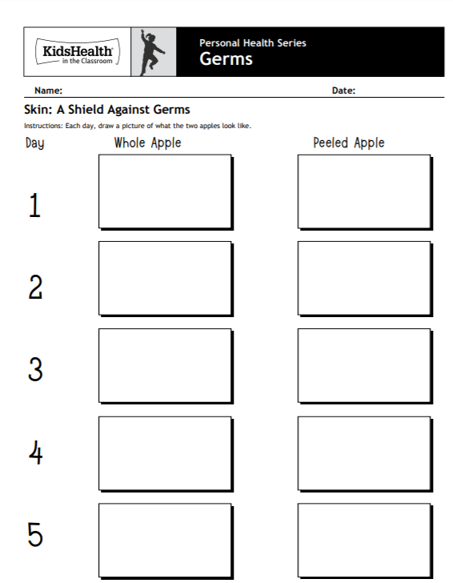

All day long, your hands touch things that have lots of tiny germs all over them. After playing all day, do you think it would be a good idea to go eat with those hands? What could happen if you did that? Color the pictures on your "Washing My Hands" handout and number them to put them in the right order.

